**Project Based Learning Report**

on

**Wave propagation in good conductors**

Submitted in the partial fulfillment of the requirements

For the Project based learning in (**Electromagnetic Waves & Propagation**)

in

Electronics & Communication Engineering

By

**2014111122 Akhil Subhash**

**2014111134 Aryan Verma**

**2014111136 Manvendra Vikram**

Under the guidance of Course In-charge

Prof. Vikas Kaduskar

Department of Electronics & Communication Engineering

Bharati Vidyapeeth

(Deemed to be University)

College of Engineering,

Pune – 4110043

**Academic Year: 2021-22**

**Bharati Vidyapeeth**

**(Deemed to be University)**

**College of Engineering,**

**Pune – 411043**

**DEPARTMENT OF ELECTRONICS & COMMUNICATION ENGINEERING**

**CERTIFICATE**

Certified that the Project Based Learning report entitled, **“Wave Propagation in good conductors”** is work done by

**2014111122 Akhil Subhash**

**2014111134 Aryan Verma**

**2014111136 Manvendra Vikram**

in partial fulfillment of the requirements for the award of credits for Project Based Learning (PBL) in **Electromagnetic Waves & Propagation** of Bachelor of Technology Semester IV, in Branch name.

**Date:23/05/2022**

**Prof. Vikas Kaduskar Dr. Tanuja S. Dhope**

**Course In-charge PBL Co-Ordinator**

**Dr. Arundhati A. Shinde**

**Professor & Head**

**ELECTRONICS & COMMUNICATION ENGINEERING**

**Index: -**

* Topic
* Introduction to SCILAB
* Introduction to MATLAB
* Introduction to Waveguides
* Problem Statement with Solution
* Explanation of the code
* Screenshot of program performed on MATLAB
* Screenshot of program performed on SCILAB
* End of Presentation.

**Introduction to SCILAB**

**Scilab** is a [free and open-source](https://en.wikipedia.org/wiki/Free_and_open-source), cross-platform [numerical computational](https://en.wikipedia.org/wiki/Numerical_analysis) package and a [high-level](https://en.wikipedia.org/wiki/High-level_programming_language), numerically oriented [programming language](https://en.wikipedia.org/wiki/Programming_language). It can be used for [signal processing](https://en.wikipedia.org/wiki/Signal_processing), [statistical analysis](https://en.wikipedia.org/wiki/Statistical_analysis), [image enhancement](https://en.wikipedia.org/wiki/Image_processing), [fluid dynamics](https://en.wikipedia.org/wiki/Fluid_dynamics) simulations, [numerical optimization](https://en.wikipedia.org/wiki/Optimization_(mathematics)), and modeling, simulation of explicit and implicit [dynamical systems](https://en.wikipedia.org/wiki/Dynamical_system) and (if the corresponding toolbox is installed) symbolic manipulations.

Scilab is one of the two major open-source alternatives to [MATLAB](https://en.wikipedia.org/wiki/MATLAB), the other one being Octave. Scilab puts less emphasis on syntactic compatibility with MATLAB than Octave does, but it is similar enough that some authors suggest that it is easy to transfer skills between the two systems.

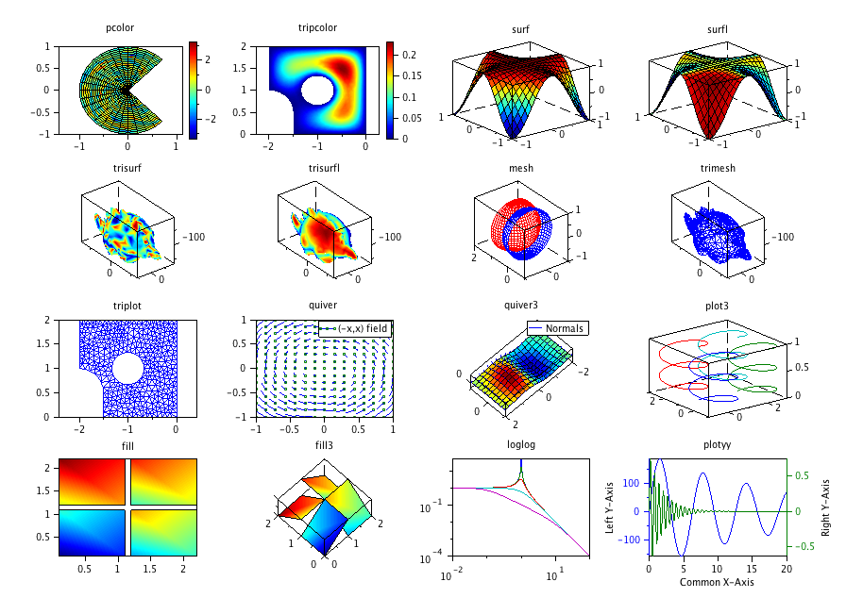Scilab is a high-level, numerically oriented programming language. The language provides an [interpreted](https://en.wikipedia.org/wiki/Interpreted_language) programming environment, with [matrices](https://en.wikipedia.org/wiki/Matrix_(mathematics)) as the main [data type](https://en.wikipedia.org/wiki/Data_type). By using matrix-based computation, [dynamic typing](https://en.wikipedia.org/wiki/Dynamic_typing), and [automatic memory management](https://en.wikipedia.org/wiki/Garbage_collection_(computer_science)), many numerical problems may be expressed in a reduced number of code lines, as compared to similar solutions using traditional languages, such as [Fortran](https://en.wikipedia.org/wiki/Fortran), [C](https://en.wikipedia.org/wiki/C_(programming_language)), or [C++](https://en.wikipedia.org/wiki/C%2B%2B). This allows users to rapidly construct [models](https://en.wikipedia.org/wiki/Computer_simulation) for a range of mathematical problems. While the language provides simple matrix operations such as multiplication, the Scilab package also provides a library of high-level operations such as [correlation](https://en.wikipedia.org/wiki/Correlation) and complex multidimensional arithmetic.

**Introduction to MATLAB**

**MATLAB** (an abbreviation of "MATrix LABoratory") is a [proprietary](https://en.wikipedia.org/wiki/Proprietary_software) [multi-paradigm](https://en.wikipedia.org/wiki/Multi-paradigm_programming_language) [programming language](https://en.wikipedia.org/wiki/Programming_language) and [numeric computing](https://en.wikipedia.org/wiki/Numerical_analysis) environment developed by [MathWorks](https://en.wikipedia.org/wiki/MathWorks). MATLAB allows [matrix](https://en.wikipedia.org/wiki/Matrix_(mathematics)) manipulations, plotting of [functions](https://en.wikipedia.org/wiki/Function_(mathematics)) and data, implementation of [algorithms](https://en.wikipedia.org/wiki/Algorithm), creation of [user interfaces](https://en.wikipedia.org/wiki/User_interface), and interfacing with programs written in other languages.

Although MATLAB is intended primarily for numeric computing, an optional toolbox uses the [MuPAD](https://en.wikipedia.org/wiki/MuPAD) [symbolic engine](https://en.wikipedia.org/wiki/Computer_algebra_system) allowing access to [symbolic computing](https://en.wikipedia.org/wiki/Symbolic_computing) abilities. An additional package, [Simulink](https://en.wikipedia.org/wiki/Simulink), adds graphical multi-domain simulation and [model-based design](https://en.wikipedia.org/wiki/Model-based_design) for [dynamic](https://en.wikipedia.org/wiki/Dynamical_system) and [embedded systems](https://en.wikipedia.org/wiki/Embedded_system).

As of 2020, MATLAB has more than 4 million users worldwide. They come from various backgrounds of [engineering](https://en.wikipedia.org/wiki/Engineering), [science](https://en.wikipedia.org/wiki/Science), and [economics](https://en.wikipedia.org/wiki/Economics).

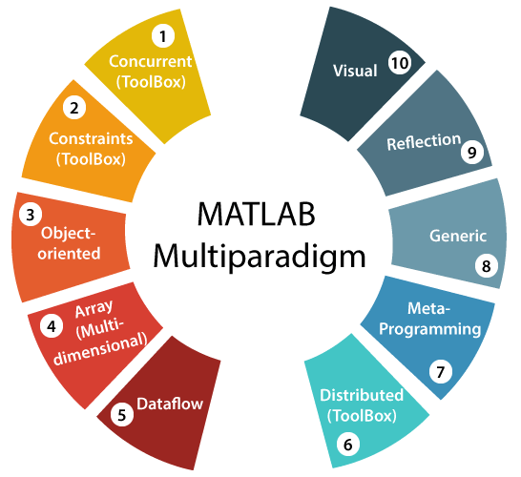MATLAB was invented by mathematician and computer programmer [Cleve Moler](https://en.wikipedia.org/wiki/Cleve_Moler).The idea for MATLAB was based on his 1960s PhD thesis.Moler became a math professor at the [University of New Mexico](https://en.wikipedia.org/wiki/University_of_New_Mexico) and started developing MATLAB for his students as a hobby. He developed MATLAB's initial linear algebra programming in 1967 with his one-time thesis advisor, [George](https://en.wikipedia.org/wiki/George_Forsythe) Forsythe. This was followed by [Fortran](https://en.wikipedia.org/wiki/Fortran) code for linear equations in 1971.In the beginning (before version 1.0) MATLAB "was not a programming language; it was a simple interactive matrix calculator. There were no programs, no toolboxes, no graphics. And no ODEs or [FFTs](https://en.wikipedia.org/wiki/FFT)."

**Penetration depth and Intrinsic impedance.**

**Attenuation**

Attenuation defines the rate of amplitude loss an EM wave experiences as it propagates. The attenuation of an EM wave is defined by the parameter β. For a downgoing planewave, the attenuation formula is given by:

A(z)=A0eβz

where absolute A is the amplitude, A0 is the absolute amplitude at z = 0 m and:

**Skin Depth**

Skin depth defines the distance a wave must travel before its amplitude has decayed by a factor of 1/e. The skin depth is the reciprocal of the decay constant β. Thus:

δ=1/β=1/ω(μϵ/2[(1+σ2ϵ2ω2)1/2−1])1/2

Since β depends on the frequency and the physical properties of the media, so does the skin depth. For a general case, the skin depth can be considered a fairly complicated function. However, approximations exist in the quasi-static and wave regimes.

**Intrinsic Impedance**

The intrinsic impedance or wave intrinsic impedance of an electromagnetic wave traveling through a medium can be given by the ratio of its electric to magnetic field intensities, that is, E/H. For a uniform plane wave traveling in a given medium, E/H is a constant and provides the impedance.

The intrinsic impedance is complex-valued and the magnitude can be given as follows:

## Intrinsic Impedance Values

The intrinsic impedance value varies with each medium, as the 𝝈, 𝜇, 𝜖 are different for different mediums. Any medium in which the electromagnetic wave propagates can be compared with that of free space using the relative permeability and permittivity values represented by 𝜇r, and 𝜖r.

### Lossy Medium

In a lossy medium, the intrinsic wave impedance is complex. In such a medium, the electric and magnetic fields exponentially decay in the direction of wave propagation. The electric and magnetic fields are out of phase by an angle equal to the phase angle of the intrinsic impedance.

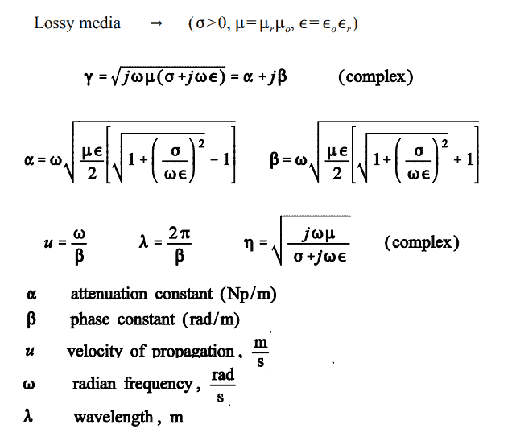

### Lossless Medium

In a lossless medium, the intrinsic wave impedance is purely real. As there is no phase angle associated with intrinsic impedance in a lossless medium, the electric and magnetic fields are in phase with each other.

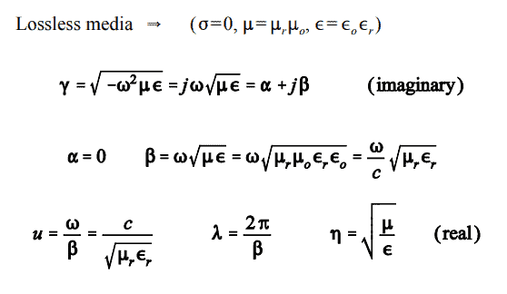

### Free Space

Substituting the values of permeability and permittivity of air in the intrinsic impedance equation, the value corresponding to free space is obtained as 120π, which is approximately equal to 377Ω.

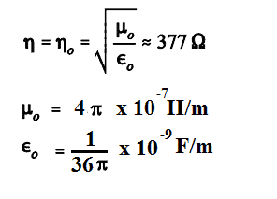

**Problem Statement :-**

consider plane wave propagation in water, but at the much higher microwave frequency of 2.5 GHz. At frequencies in this range and higher, dipole relaxation and resonance phenomena in the water molecules become important. Real and imaginary parts of the permittivity are present, and both vary with frequency. At frequencies below that of visible light, the two mechanisms together produce an e" that increases with increasing frequency, reaching a local maximum in the vicinity of 1010 Hz. e decreases with increasing frequency. At 2.5 GHz, dipole relaxation effects dominate. The permittivity values are = 78 and 7.

**Solution :-**

We have,

The first calculation demonstrates the operating principle of the microwave oven. Almost all foods contain water, and so can be cooked when incident microwave radiation is absorbed and converted into heat. Note that the field will attenuate to a value of e-1 times its initial value at a distance of 1/α= 4.8 cm. This distance is called the penetra tion depth of the material, and of course is frequency-dependent. The 4.8 cm depth is reasonable for cooking food, since it would lead to a temperature rise that is fairly uniform throughout the depth of the material. At much higher frequencies, where e" is larger, the penetration depth decreases, and too much power is absorbed at the surface: at lower frequencies, the penetration depth increases, and not enough overall absorption occurs. Commercial microwave ovens operate at frequencies in the vicinity of 2.5 GHz

In a calculation very similar to that for α, we find β= 464 rad/m. The wavelength is λ=2π/β= 1.4 cm, whereas in free space this would have been λo = c/f = 12 cm.

The intrinsic impedance is found to be

**Explanation of the code :-**

Program to determine the cutoff frequency of the first waveguide (m=1):

* Open MATALB / SCILAB.
* Use CLEAR Command to clear all the programs which are already opened.
* Assign the dielectric constant of the microwave to variable – er1, er2.
* Assign the relative permittivity to variable – er0.
* Write the free space intinsic impedance – etta0
* Write the free space velocity (in m/sec) and assign it to variable – C.
* Note down the formula of Attenuation & Intrinsic constant and store in variable – alpha & etta.
* Finally, display alpha & etta.

**Program to determine Impedence & Attenuation on MATLAB**

**Program to determine Impedence & Attenuation on SCILAB**

**Project Outcome: -**

From this project, we learnt about properties of Electromagnetic waves in good conductors, about their impedence and the penetration depth and demonstrated mathematical skills related with differential, integral and vector calculus.

**Project Conclusion: -**

From this project, we gained the knowledge of two softwares – MATLAB and SCILAB. We learnt how to use them efficiently. We learnt about the concept of Electromagnetic wave in good conductors and solved a problem statement on it. We also written a program to determine the Attenuation and Impedance both on MATLAB and SCILAB, and it was successfully performed.